**UNIT 1:**

*Introducing HTML*



YOU CAN ANSWER THESE!



Oct 15, 2021

Ronald A. Dy Tioco Jr.

**Name:** __________________________________ **Date:** ___________________

BSIT 3K

**Course & Section:** ________________________ **Score:** __________________

1. Does using heading tags are better than using the bold element?

Depending on usage. You cannot just use header tags randomly if you want it. They are called headers because they are mostly used on headers, otherwise we use bold or strong instead.

1. What are the differences of paragraph and preformatted text elements?

Paragraph tags are doesn’t read newlines, we have to use <br> unlike in preformatted text, it follows whatever is written inside the <pre> tag. But paragraph tags are much more common to use.

1. What are the basic text formats?

* <b> - **Bold text**
* <strong> - **Important text**
* <i> - *Italic text*
* <em> - *Emphasized text*
* <mark> - Marked text
* <small> - Smaller text
* <del> - ~~Deleted text~~
* <ins> - Inserted text
* <sub> - Test Subscript text
* <sup> - Test Superscript text

1. What file types are accepted for images in HTML?

In browsers they don’t support some image formats, but here are some of the image formats that most browsers support:

* jpeg
* gif
* png
* apng
* svg
* bmp
* bmp
* ico
* png
* ico

1. What does the anchor element do?

It adds a Hypertext REFerence to create a link to another webpage, it can also be used to identify and navigate through sections within a document or webpage.

1. What are character entities?

They are reserved characters used in a markup language. For html, if you use misuse these symbols: (< / >), your browser may mix them with other tags and it may lead to undesirable results.

1. What are Emojis?

They are characters from UTF-8 character set. It may look like icons, or images but they are not. They have been around since 1990s.

**Name:** __________________________________ **Date:** ___________________

BSIT 3K

Oct 15, 2021

Ronald A. Dy Tioco Jr.

**Course & Section:** ________________________ **Score:** __________________

Program an HTML document to have the same output as given. Save your work as **internationalPlayers.html**.

Output:

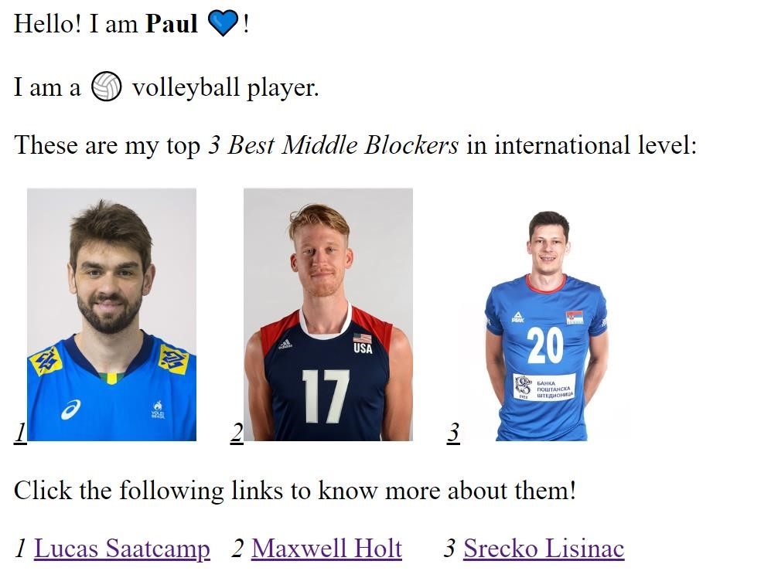

**Instructions:**

1. On the name in the first paragraph, change it to your **nickname**. Do not forget to make it **important**. Use an emoji that you think best represents you.
2. In the second paragraph, use the numbers **127952** for the emoji.
3. The words "3 Best Middle Blockers" shall be **emphasized** in the third paragraph.
4. The images are available in this link: <https://bit.ly/imagesMiddleBlockers>
5. Create a folder named **images** and download and save the images on the given link on the created folder.

(***NOTE:*** The folder images must be in the same directory as your HTML file.)

|  |  |  |  |  |  |
| --- | --- | --- | --- | --- | --- |
| **Em** | | **oji Entity** | | | |
|  | 👍 |  | &# | 128077; |  |
| 💯 | |  | &#128175; | | |
|  | 😃 |  | &# | 128512; |  |
| 😂 | |  | &#128514; | | |
| 😪 | |  | &#128554; | | |
|  | 🙏 |  | &#128591; | | |
|  | 🎓 |  | &#127891; | | |